# SEGEMENT 2 :

1. **Write SQL queries to retrieve the total number of orders, total revenue, and average order value.**

* **The operations team needs to track the agent who has handled the maximum number of high-grade customers. Write a SQL query to find the agent_name who has the highest count of customers with a grade of 5. Display the agent_name and the count of high-grade customers.**

From analysis we get to know there no customer in order table that have grade on 5. The highest grade of customer that had some transaction is of 3.

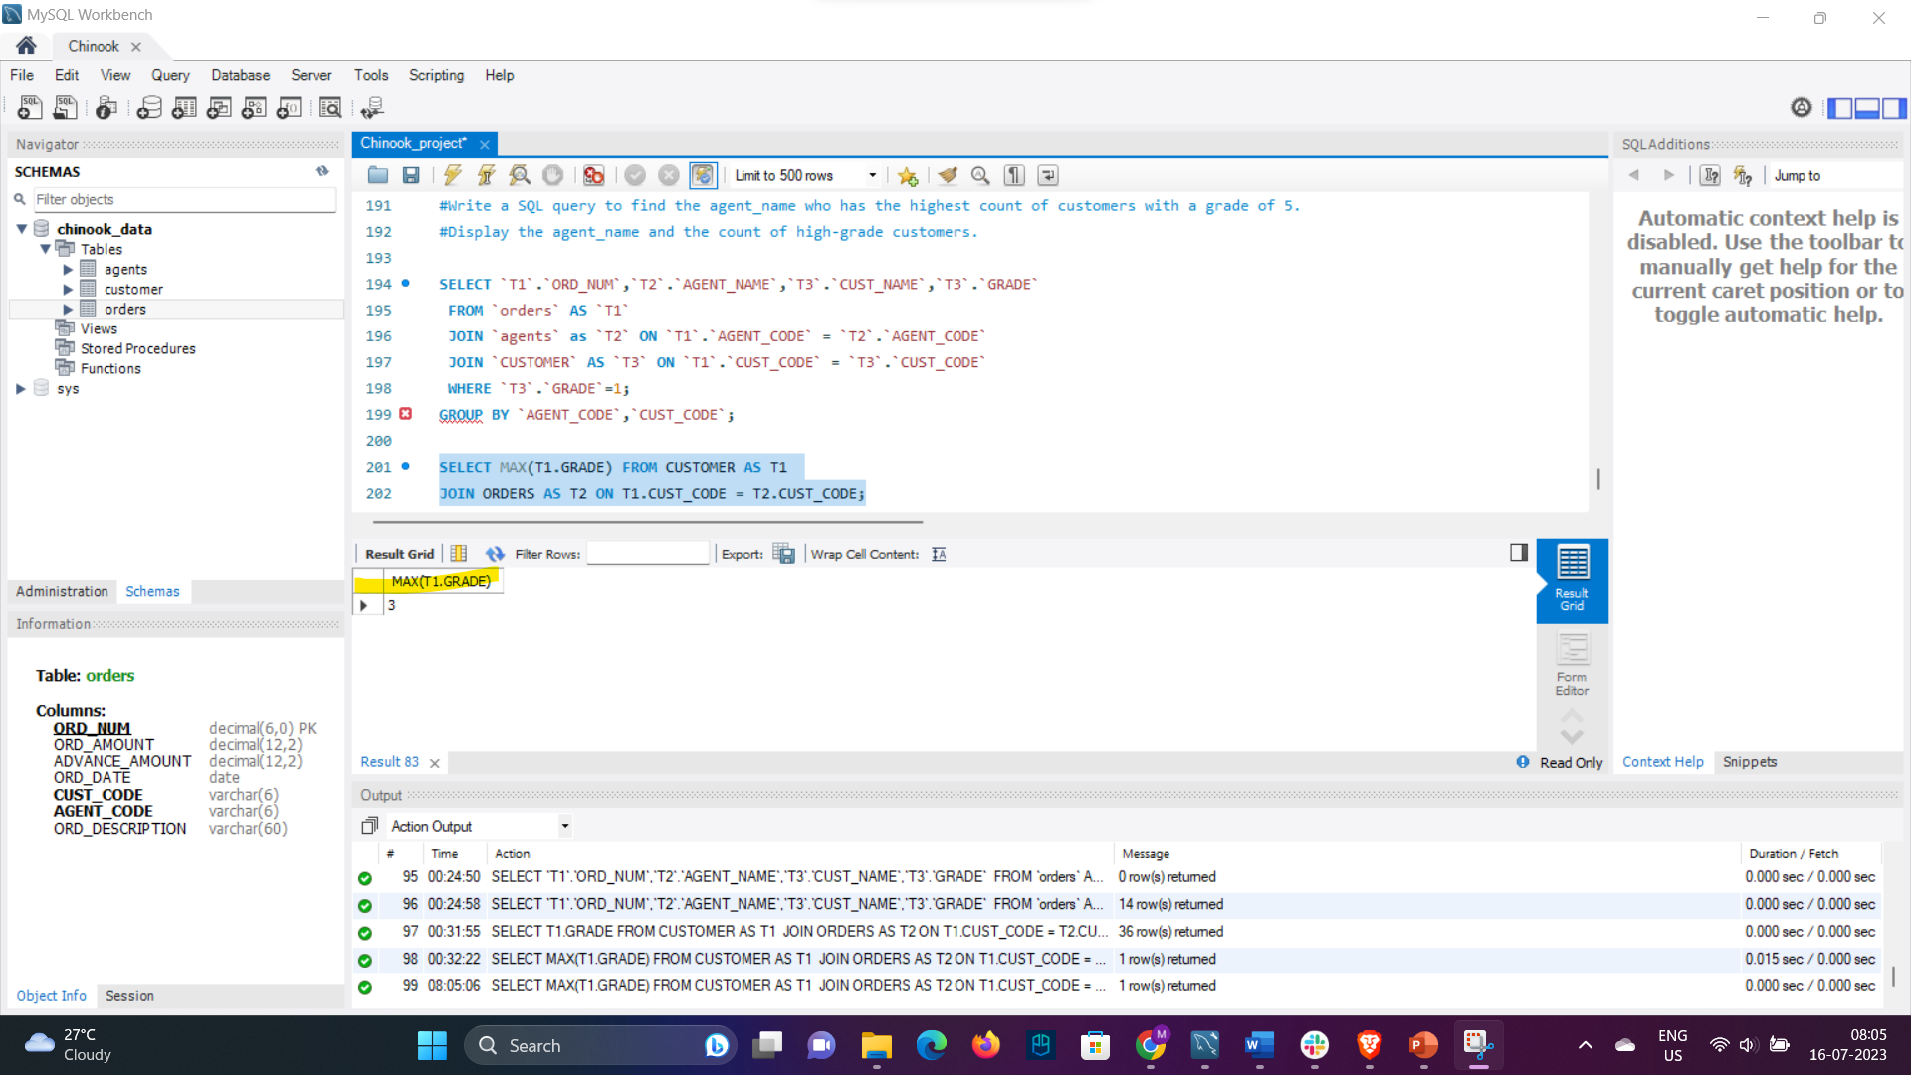

Hence updating the output, now giving agent_name who have highest customer with grade 3.



Grouping the names by agent_Code so that only unique names list is showing up.

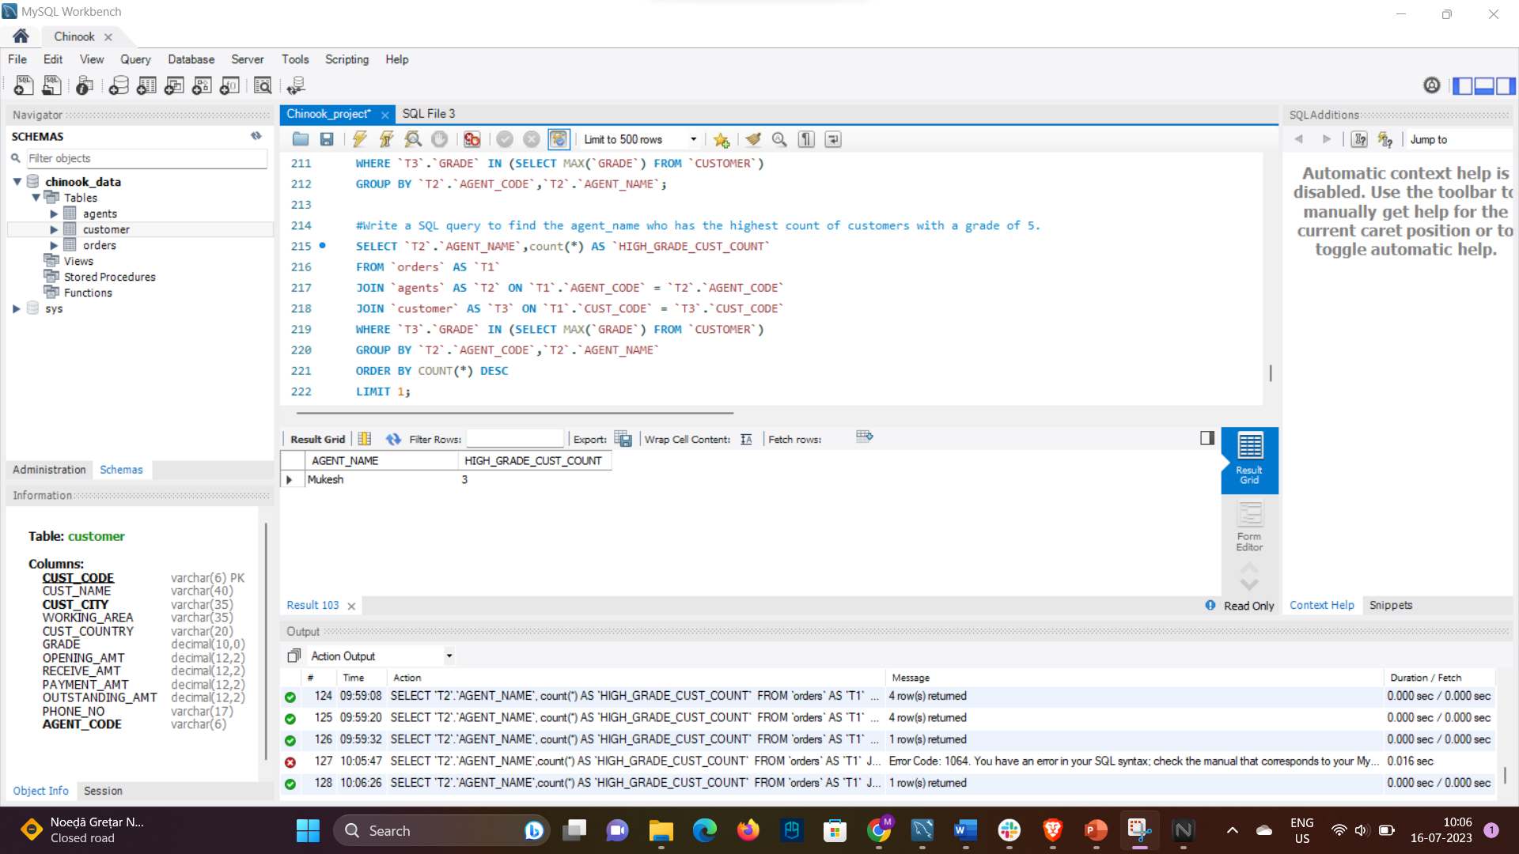

* The company wants to identify the most active customer cities in terms of the total order amount. Write a SQL query to find the top 3 customer cities with the highest total order amount. Include cust_city and total_order_amount in the output.

